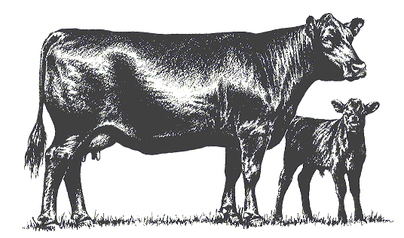

Buckingham Cattlemen's
Association, Inc.

Post Office Box 95

Buckingham, Virginia, 23921

*Please make sure your bull selection qualifies for the genetic component of the VQA program!! Angus have to be +77 for YW EPD.

April 22, 2019
Re: August 5th Feeder Calf Sale
Dear member:

August 5th will soon be upon us and we need to begin our marketing program now. We would like to continue to have a dinner during the sale for consignors, if you bring a guest please call in advance and be prepared to pay $10/extra person. Please verify that you will be coming by calling the Buckingham County Extension office at (434) 969-4261. Please call in your tag order to the Extension office by May 3rd. Please bring copies of your calving records to the Extension office by tag pick up. If you are a first time seller the screening committee will make arrangements with you for a farm visit.
First vaccinations should be given at turn out in the spring after calf is 4 months old. Second vaccination of each must be given not less than 21 days prior to sale. Vaccinations (All Pfizer Products) ** Please note changes**
- IBR, PI3, BRSV, BVD(Bovi-Shield Gold 5) + Pasturella (One Shot): This vaccination is now available in a combination, BOVI-SHIELD GOLD ONE SHOT
- 7-Way Clostridial (Ultrabac 7 or Ultrachoice) No longer needs to include Somnus
- Dewormed (we recommend the injectable Dectomax, but is at producer discretion)
- Calf Castration Date: No later than April 15
- Weaning Date: All calves weaned by June 21st
- Second set Vaccinations: no later than July 15th (Not during GRADING)
- Weighing cattle: To be helpful, please weigh calves TWICE, at weaning or one week post weaning (record date) and for a SECOND TIME no later than July 8th,(record date) **MAKE SURE THE SCALES YOU USE ARE ACCURATE. This is for your benefit and help to better estimate gain. If weighing twice is impossible, make sure you have the pre-sale weight before grading.
- There is a place at the top of the weigh sheets for Feed info, please fill that in, we will fill in flesh score during grading.
- Grading Dates: July 8th through the 12th
- Load out Dates: August 7th and after
In efforts to keep the BCA’s dependable reputation on quality cattle; the BCA expects that all cattle consigned to the sale; be delivered to the load out facility on the proper day unless the calves are visibly sick or emaciated. The BCA will not accept any calf; that weighs less than 450 pounds, a calf showing signs of being a stag, being sick, qualifying as an ‘S’ frame, and/or qualifying as a ‘3’ on day of load out. If you deliver such a calf to the BARN for load out, the animal will be rejected and you will be expected to remove it from the facility that day. Negligence will incur a letter of probation.
We will let you know about the ear tags as soon as they are available. You will receive a worksheet to record information such as matching farm tag to BCA Sale tags, color, a space for two weights and the weigh dates, and sex of each calf. All calves must be ear tagged in the left ear and weighed prior to grading.
If you have any load out or lot questions, please feel free to call the Extension office for current information. This information may change, so please use information given out on sale night to sort your cattle for load out. We look forward to hearing from you.

Sincerely,
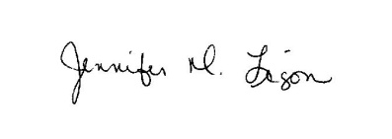
Jennifer Ligon
ANR Agent
2019 BCA Feeder Sale Requirements
Naturals
The only ‘natural’ loads to be sold in the feeder calf sale will be one owner loads. There will be no co-mingled natural loads.

Genetic Selection:
Board action requires that the sires of any co-mingled calves in the BCA feeder calf sale will be black Angus, Gelbvieh, Simmental or any combination thereof. If you are large enough to sell your own trailer load lot, you can use other breed or breed crosses with the approval of the marketing committee, surplus calves may or may not fit co-mingled loads. All bulls must meet VQA standards. Final decisions on included calves will be made by the Executive Secretary and the Marketing Committee.

Bull Certification:
It is the producers’ responsibility to supply a list of bulls that have sired the calves that are being offered for sale. The list needs to include: the name, the breed, registration number, the year born, and the yearling weight EPD. If yearling EPDs are not available then weaning weight EPDs are used. If you use a multiple bull-breeding unit all bulls that enter that pasture must meet the minimums. For valid EPDs the bulls must be registered, with EPDs assigned by the breed registry. The Virginia Cattlemen’s Association has revised the EPD requirements. They are below, all bulls purchased from this point on, shall meet these requirements.
Breed | Current YW EPD Specification (adopted in 2013) | Current YW EPD Spec.  Breed Rank
Angus | +77 | Top 80%
Gelbvieh (PB) | +82 | Top 55%
Gelbvieh Balancer | +87 | Top 70%
Tags:
We plan order tags as a group and you can pick them up at the Buckingham Extension office. Price per tag is $1.35.

Grading Calves:
As the number of calves in the sales grows so does the time involved in grading the cattle. It will be the producers’ responsibility to have their calves up to be graded. The main item is that calves can be driven through a gate a few at a time for a better view. You will also need to provide an accurate count as to the number of steers and the number of heifers. Number 3s (light muscle) and Ss (small frame) will not be accepted.

Calving Dates:
The calving dates on your farm should be September 1st - December 31st. If you choose to calve earlier and your calves do not fit the loads we will not accept them. The calf sale advertisement specifies calves born in the above window. For those wanting to market we will allow a little lead way until you get on the program.

Weaning:
Calves must be weaned 45 days prior to the sale. They must be feed and water trough broke.

Marketing Committee:
The marketing committee consisting of three members has the right to reject any or all calves that do not meet the quality or health program set forth by the association. The VDACS Livestock Grader and the Extension Agent shall be ex-officio members of this committee.

Heifer Guarantee:
If a Buyer purchases a heifer that happens to be bred, the producer agrees to refund $300 to the Association to be forwarded to the purchaser. This is subject to a veterinarian’s certification that the heifer is pregnant and the returned ear tag verifying the farm of origin.

Stags:
If a Buyer purchases a steer that turns out to be a stag, the producer agrees to refund $250 to the Association to be forwarded to the purchaser.

Buckingham Cattlemen’s Association
P.O. Box 95
Buckingham, VA 23921

John Schlichting
2335 Diana Mill Road
Arvonia, VA 23004

